**What is it?**

This algorithm monitors hourly maximum water levels and records the timing, frequency, and duration of dune-impacts caused by elevated shoreline water levels. It uses publically available webcam images/videos, thereby reducing the need for labor intensive camera surveying and image rectification. This algorithm was designed to be accessible to all levels of the community, meaning it only processes and analyzes one webcam video at a time. However, the scripts can be easily modified and used for processing and analyzing a large number of videos.

**What is Needed to Run the Algorithm:**

Matlab Scripts:

1. Analyze_dune_collision script
2. Station_setup script
3. Get_snapshot script
4. Choose_locations script
5. Digitize_Dune script
6. Readindexframe script
7. Get_brightest_timestack script
8. Check_brightest script
9. Check_timestack script

MATLAB toolboxes:

1. signal processing toolbox
2. image processing toolbox
3. statistics and machine learning toolbox

**What to do First:**

1. **Download videos: Choice of two methods**
   1. Manual download from WebCAT: <https://secoora.org/webcat/>
      1. Can use videos from any webcam, this is just one source

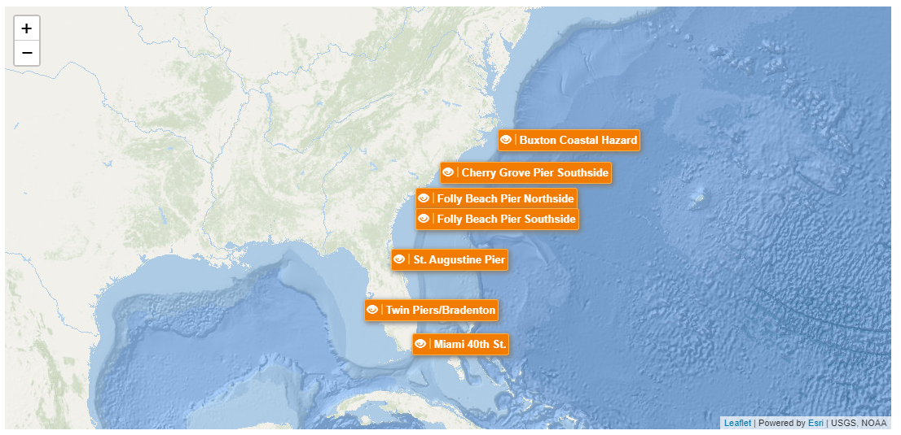

* + 1. Choose webcam site by clicking on the orange tab with site name

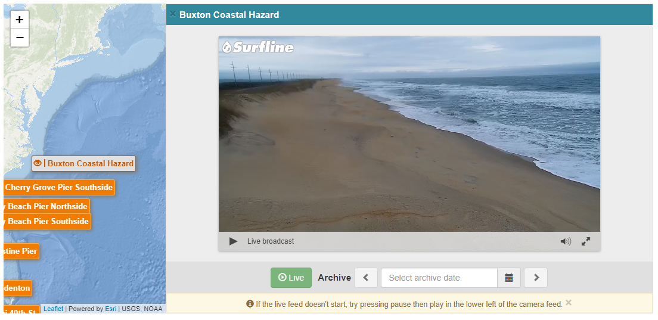

* + 1. To access archived videos, click on the box next to the calendar icon

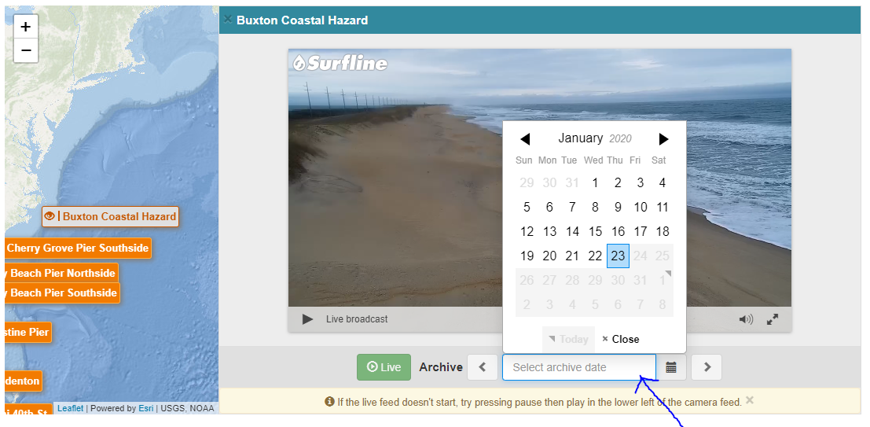

* + 1. Once date is chosen, click on the “more times” button to access all archived videos for that date

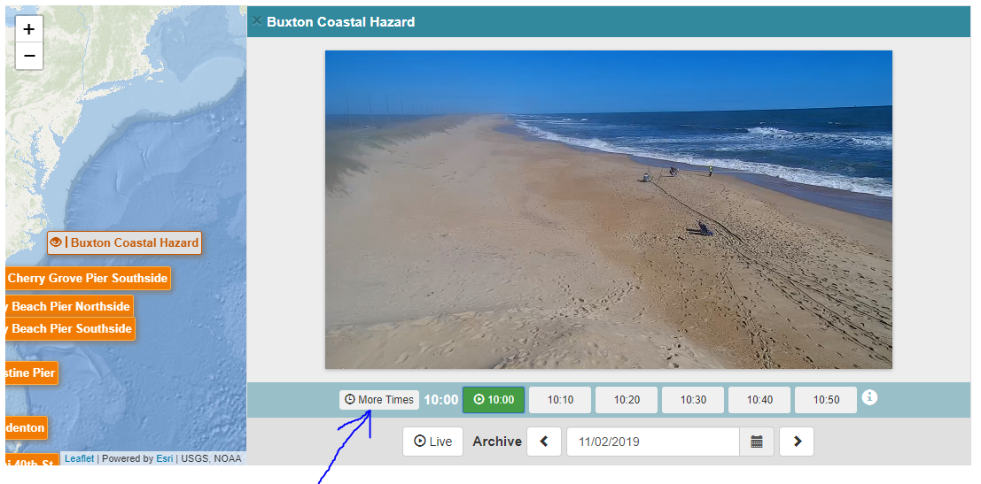

* + 1. Choose time

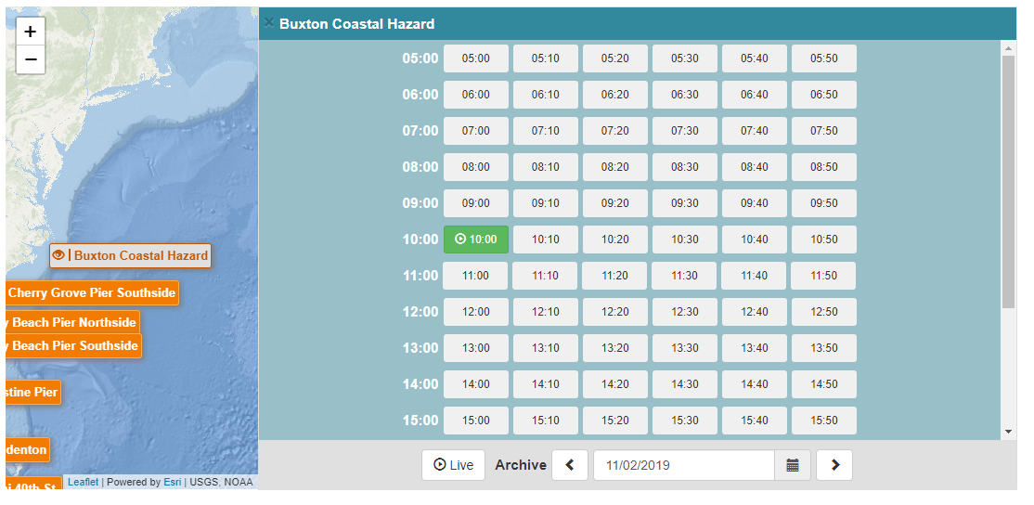

* + 1. After time is selected, choose the “I” icon to download the video

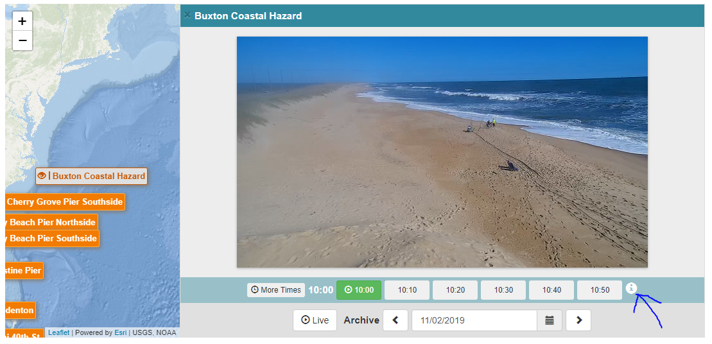

* + 1. Once “I” is selected, press “download video”

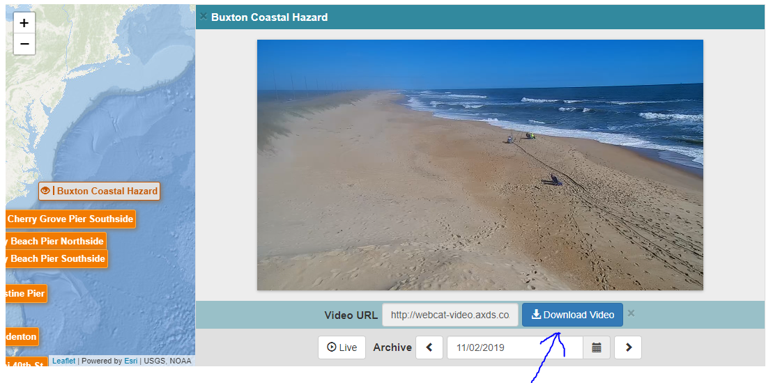

* + 1. The video will pop up. Select the 3 dots at the bottom right of the screen

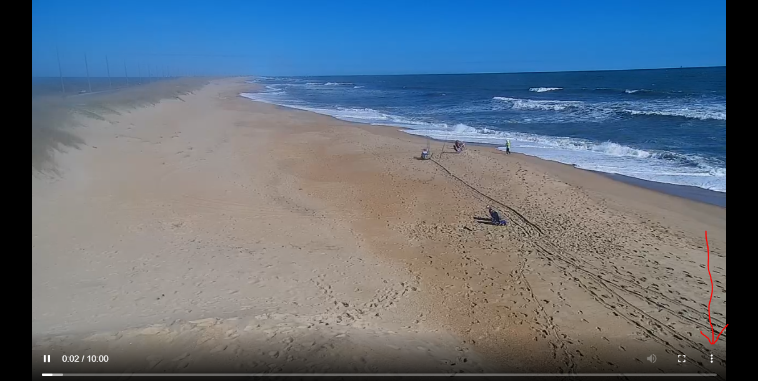

* + 1. Click download
    2. Save all downloaded videos to the same folder. Repeat steps for all other videos
  1. The clips may also be accessed via a command-line tool like wget or curl. They are named in a standard pattern:
     1. http://webcat-video.axds.co/<stationcode>/raw/<year>/<year>_<month>/<year>_<month>_<day>/<stationcode>.<year>-<month>-<day>_<time>.mp4
        1. Ex:http://webcat-video.axds.co/twinpierscam/raw/2018/2018_06/2018_06_03/twinpierscam.2018-06-03_1000.mp4
     2. Use the WebCAT tool to determine the station codes by inspecting the Video URL of any clip from that station using the Information icon.

1. **Run “Station_Setup” script**
   1. The used will need to set up each webcam location before processing a video. This step only needs to be done once, unless the view of the camera or the position of the dune changes (e.g., after a storm). The script prompts the user to define some input. These steps are in the “Station_Setup” script and should take less than 5 minutes to complete:
      1. **Identify a station name:** User will need to identify a station name that will be used for all videos from this location.
      2. **Digitize a duneline:** The user will be prompted to digitize the base of the dune. This will be used to compare to the observed water levels and determine the potential for dune erosion. DISCLAIMER: if the duneline position changes, a new duneline will need to be digitized for accurate results (e.g., after large storms or events)
      3. **Interpolate the digitized duneline:** the code with then automatically interpolate the digitized duneline.
      4. **Identify 3 locations of interest:** User chooses three locations of interest along the dune line. The algorithm will monitor water levels at these locations and determine the potential for dune erosion. The locations could correspond to low points in the dune, areas of exposed infrastructure (e.g., roadways, etc. (PICTURE). Make sure the chosen points represent the area of focus/interest.

**How does it work?**

The algorithm employs two methods for verification of a dune collision event. Both methods have strengths and weaknesses but we use them both for a more robust analysis. Thus the main script, “analyze_dune_collision,” looks for agreement between both methods:

1. Method One: This method requires the use of the brightest pixel intensity image product created in the “get_brightest_timestack” script (see picture below for brightest image example). This product shows the brightest intensity at each pixel in the image over the entire video. It should expose the highest water level on the beach during each video.

This image product is converted to the Hue, Saturation, and Value (HSV) color model. The Value channel is used to determine a threshold in pixel intensity between the water and sand. This threshold is used to contour the water line that corresponds to the maximum extent of wave runup during the video. This contoured shoreline is then compared to a previously identified duneline as seen in Figure 1 (see Station_Setup section).

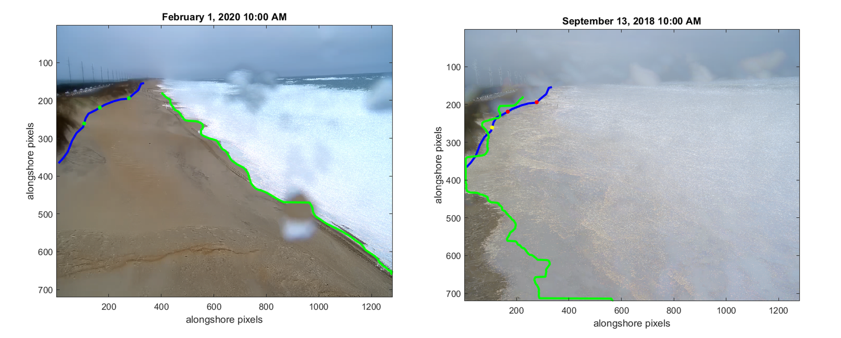

**Figure 1.**

1. Method Two: This method uses timestacks pixel intensity generated in the “get_brightest_timestack” script (Figure 2). The represent changes in the pixel intensity along a cross-shore transect at the three user-identified locations.

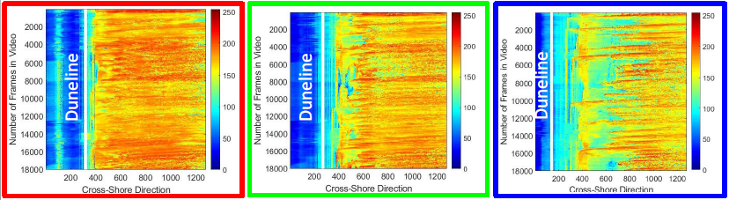

**Figure 2.**

Timestacks track the time-varying pixel intensities associated with wave runup, and therefore track shoreline position along three previously identified transects (see Station_Setup section). The time series of pixel intensity at the location of the dune line is then extracted. A threshold for dune collision events is set to three standard deviations above the average duneline pixel intensity. When pixel intensity exceeds the threshold (black horizontal line),a dune collision event is identified (Figure 3).

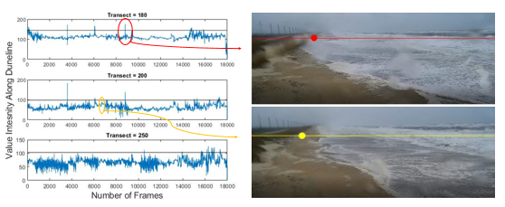

**Figure 3.**

This algorithm produces a .png image and .mat file. The .png image displays the location of the three identified transects. Each location will either be colored green, yellow, or red. A green dot represents the absence of a dune-collision event at that location during that webcam video. A yellow dot indicates that only one method marked a dune-collision event at that location. A red dot means that a dune-collision event was recorded by both methods at that location during the webcam video (see image below). Individual results from both methods will be provided in the .mat file.

**Further Improvements:**

1. Convert to python to avoid the need of MATLAB and its toolboxes
2. Automation of the dune base line based on an automatically detected line of vegetation
3. Compile all MATLAB scripts into an executable so MATLAB software is not a requirement (i.e. make scripts accessible to all users)